**LAMP** (Linux, Apache, MySQL, PHP) is an archetypal model of web service stacks, named as an acronym of the names of its original four open-source components: the Linux operating system, the Apache HTTP Server, the MySQL relational database management system (RDBMS), and the PHP programming language.

1. Install Linux using AWS AMI
2. Install Apache Webserver

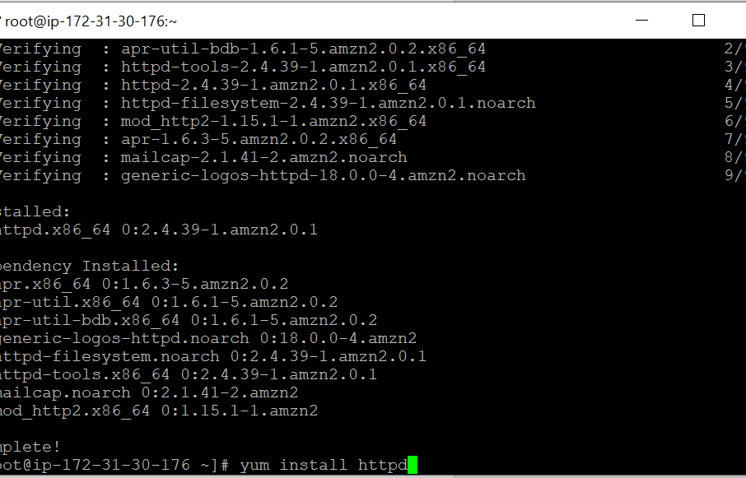

Installing PHP 7.2

amazon-linux-extras install php7.2

**cd /var/www/html  
vi test.php**

Type **i** to start the insert mode

Type **<?php phpinfo() ?>**

Type **:wq** to write the file and quit vi

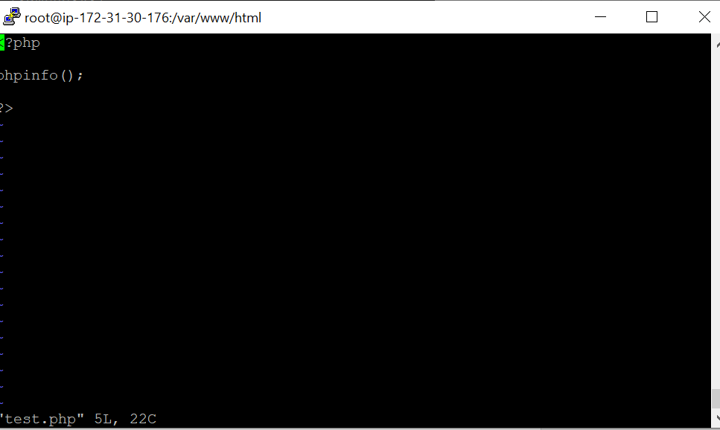

<http://34.227.53.126/test.php>

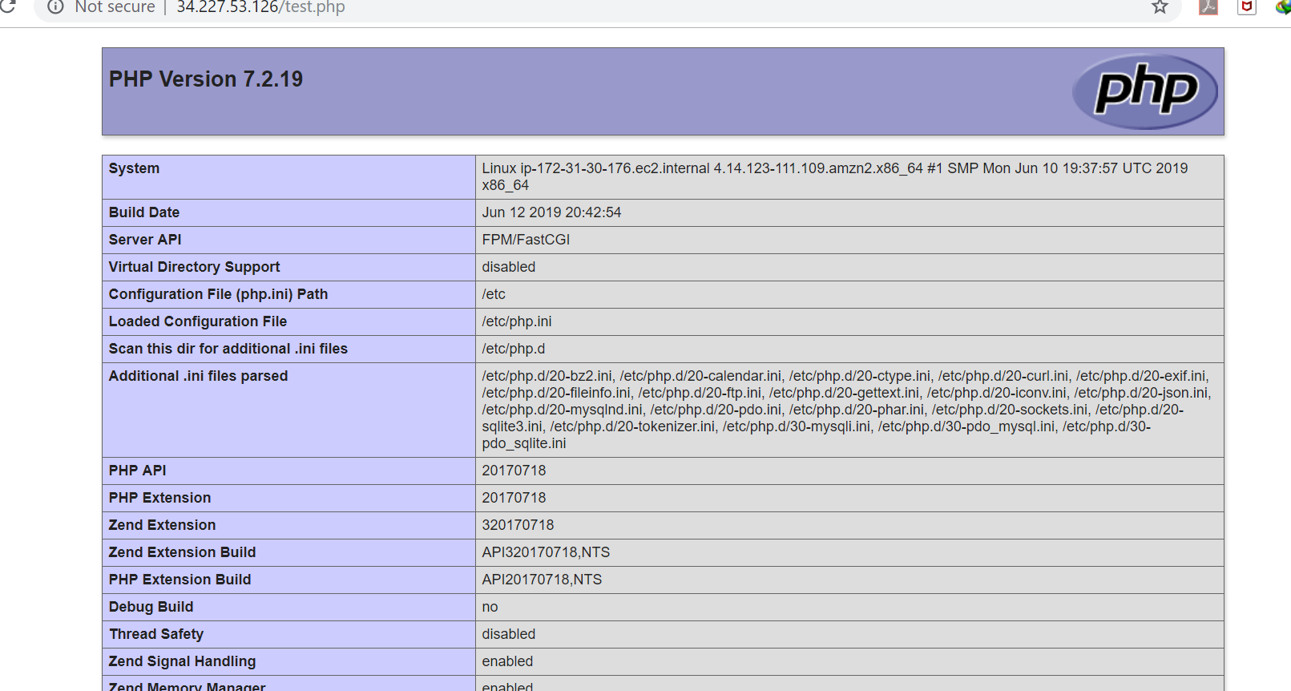

Install MySql

wget https://dev.mysql.com/get/mysql57-community-release-el7-11.noarch.rpm

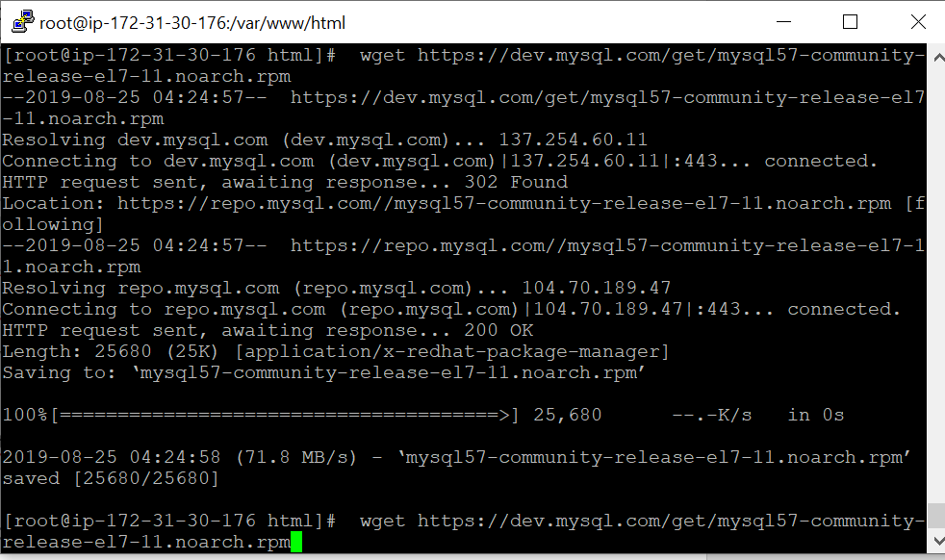

yum localinstall mysql57-community-release-el7-11.noarch.rpm

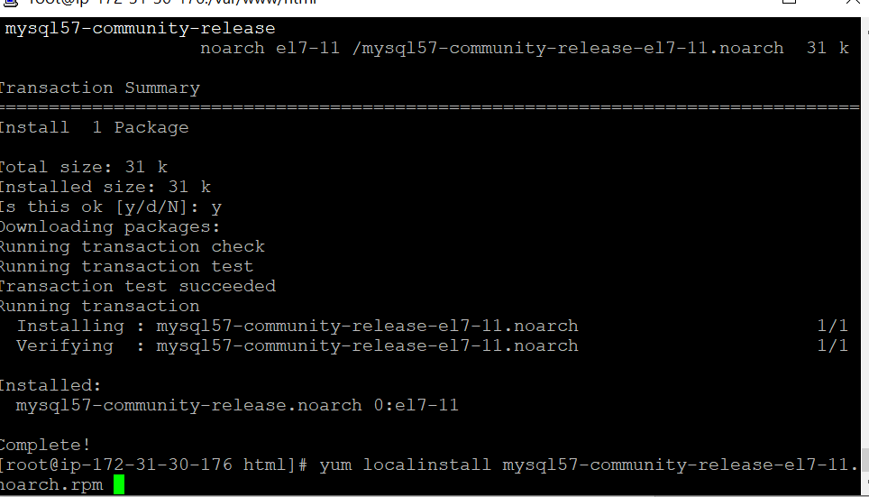

yum install mysql-community-server

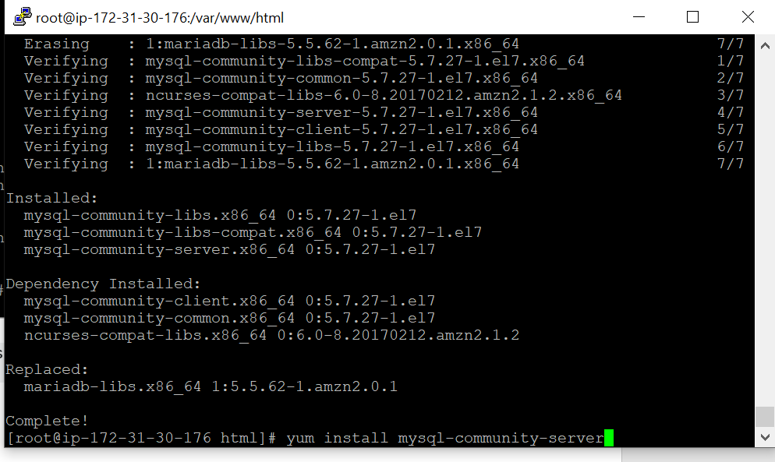

systemctl status mysqld.service

systemctl start mysqld.service

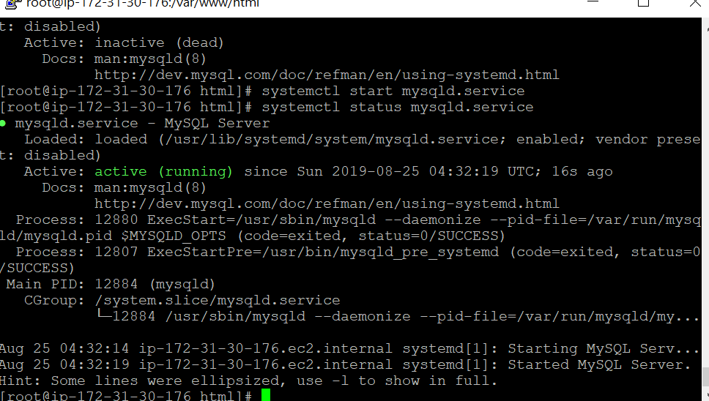

[root@ip-172-31-30-176 html]# grep 'temporary password' /var/log/mysqld.log

2019-08-25T04:32:15.798310Z 1 [Note] A temporary password is generated for root@localhost: h!Jgr(NCl6+e

[root@ip-172-31-30-176 html]#

[root@ip-172-31-30-176 html]# **mysql -u root -p**

Enter password:

Welcome to the MySQL monitor. Commands end with ; or \g.

Your MySQL connection id is 3

Server version: 5.7.27

Copyright (c) 2000, 2019, Oracle and/or its affiliates. All rights reserved.

Oracle is a registered trademark of Oracle Corporation and/or its

affiliates. Other names may be trademarks of their respective

owners.

Type 'help;' or '\h' for help. Type '\c' to clear the current input statement.

mysql>

Secure your database:  
**mysql_secure_installation**

Answer the wizard questions as follows:

1. Enter current password for root: Press return for none
2. Change Root Password: Y
3. New Password: Enter your new password
4. Remove anonymous user: Y
5. Disallow root login remotely: Y
6. Remove test database and access to it: Y

Reload privilege tables now: Y

Install WordPress

**cd /var/www/html**

**wget**[**http://wordpress.org/latest.tar.gz**](http://wordpress.org/latest.tar.gz)

**tar -xzvf latest.tar.gz**

Create the WordPress wp-config.php file:

**mv wp-config-sample.php wp-config.php  
vi wp-config.php**

